Exploratory Data Analysis using Python

Laptop Price Analysis

ARUNKUMAR A DA&DS AUGUST B

PROJECT DOCUMENTATION

EXPLORATORY DATA ANALYSIS USING PYTHON
TABLE OF CONTENT

1. | Introduction
2. | Aim
3. | Business Problem / Problem Statement
4. | Project Workflow
5. | Data Understanding
6. | Data Cleaning  Missing Values Imputation Outlier Treatment  Handling Inconsistent Values
7. | Obtaining Derived Metrics
8. | Filtering Data for Analysis
9. | Exploratory Data Analysis (EDA) - Univariate Analysis
10. | Bivariate Analysis
11. | Multivariate Analysis
12. | Overall Insights from Analysis
13. | Conclusion

INTRODUCTION

In today’s digital era, laptops have become an essential tool for education, business, entertainment, and personal use. With the rapid advancement of technology, the laptop market offers a wide variety of options across different brands, specifications, and price ranges. This diversity often makes it challenging for consumers to select the right laptop, while manufacturers and retailers face difficulties in setting competitive prices that match consumer expectations.

This project focuses on applying Exploratory Data Analysis (EDA) techniques to a laptop dataset in order to uncover meaningful insights about pricing patterns. The dataset includes key features such as brand, laptop type, processor, RAM, storage capacity, GPU, screen resolution, operating system, and price. By cleaning and analyzing the data, we aim to identify trends, relationships, and outliers that influence laptop prices.

The study emphasizes how technical specifications like RAM, storage, and CPU performance impact costs, while also considering the role of brand reputation and operating system preferences. Visualizations and statistical methods are used to better understand market behavior and highlight differences across product segments. Ultimately, this analysis provides valuable insights for consumers, manufacturers, and retailers, enabling them to make more informed, data-driven decisions.

AIM OF THE PROJECT
  - To perform Exploratory Data Analysis (EDA) on a laptop dataset to understand pricing trends.
  - To clean and preprocess the dataset by handling missing values, outliers, and inconsistent data.
  - To analyze key specifications (RAM, CPU, GPU, storage, screen resolution) that influence laptop prices.
  - To study the impact of brand and operating system on pricing patterns.
  - To use statistical methods for identifying correlations and testing hypotheses between features.
  - To apply data visualization techniques for clear representation of distributions, relationships, and trends.
  - To generate insights that help consumers make better purchase decisions based on specifications and price.
  - To provide useful recommendations for manufacturers and retailers for product positioning and competitive pricing strategies.

PROBLEM STATEMENT

The laptop market is highly competitive and diverse, offering a wide range of models across different brands, specifications, and price categories. Customers often face challenges in choosing the right laptop because pricing varies significantly depending on features such as RAM, storage, processor type, graphics, display resolution, and operating system. At the same time, manufacturers and retailers struggle to position their products competitively in the market while ensuring profitability. Without proper data-driven insights, decision-making for both consumers and sellers can be inefficient and unclear.
To address this challenge, there is a need for a systematic analysis of laptop data that highlights the key factors influencing pricing. By applying Exploratory Data Analysis (EDA) techniques, it becomes possible to clean, organize, and interpret the dataset, uncover hidden patterns, detect outliers, and identify relationships between specifications and price. Such analysis will not only assist consumers in making informed purchase decisions but also help manufacturers and retailers in developing competitive pricing strategies, optimizing product placement, and understanding market trends more effectively.

PROJECT WORKFLOW
- Data Collection : Loaded restaurant inspection dataset and examined basic structure. Verified data dimensions and initial data quality
- Data Cleaning & Preprocessing : Handled missing values and converted data types. Created simplified categorical variables from complex descriptions
- Exploratory Data Analysis (EDA) : Conducted univariate analysis of key variables. Performed bivariate analysis to examine relationships. Applied multivariate analysis for deeper insights.
- Visualization & Insights : Created charts to identify patterns and trends . Examined distributions and relationships visually.
- Feature Engineering : Developed new categorical groupings and binary indicators. Generated time-based variables for analysis.
- Recommendations : Summarized key findings and patterns . Provided insights for stakeholders.

Data Understanding
The dataset (laptopData.csv) contains detailed information about different laptops, including their specifications, features, and prices. Each row represents a laptop model, while the columns provide attributes such as brand, processor, RAM, storage, GPU, display, operating system, and price

  - Rows – 1,303

Columns – 12
Key Variables
  - Company
  - TypeName
  - Screen Resolution
  - CPU
  - RAM
  - GPU
  - Memory
  - Operating System
  - Price
This dataset had 10 object columns, 2 in float. One column is unnecessary and carried Index of the dataset. Columns like latitude and longitude are neglected because, not relevant here otherwise it can be used for more map based analysis.

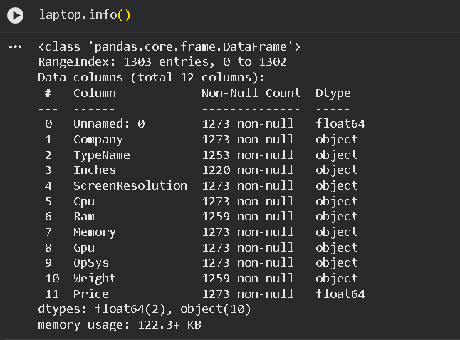

Cleaning and Transformation
Data cleaning is the next step in EDA, Cleaning is one of the most important step in Data Science , clean data ensure accurate and proper insights . Data Cleaning steps include handling missing values, Changing columns names, Dropping Irrelevant columns, Formatting the data into proper format.

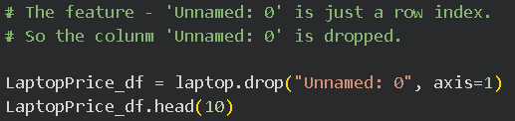
First I drop the Unnamed: 0 column. Because it shows index value and for better analysis.
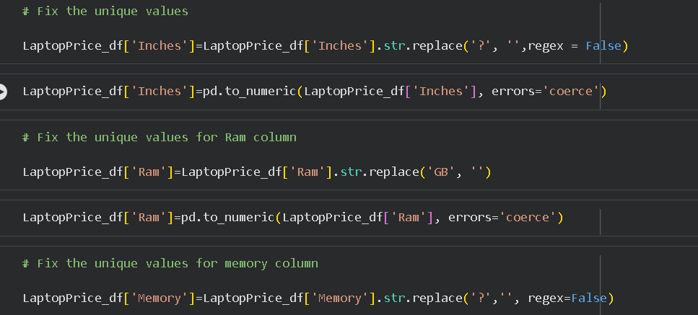
Then check the unique values and replace str.replace() function.
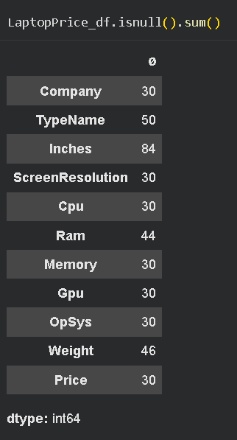
The null values are filled by using fillna().
Numeric columns are filled with median value. Because the data are normally distributed in this dataset.
Text and mixed columns are filled with mode value.

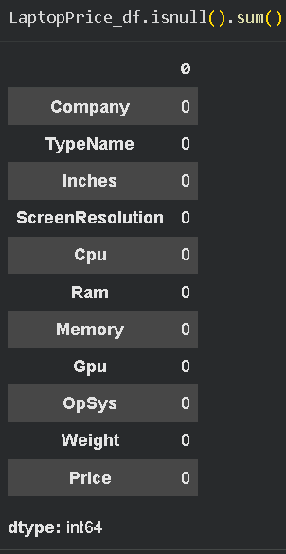
After filling null values the dataset don’t have null values.

After I check the dataset have any duplicate values and I find 57 duplicates. So I drop the duplicate values using drop_duplicates() function.

Feature Engineering
Feature Engineering is the process of creating, transforming, or selecting variables from raw data to make them more useful for analysis or modeling.
This dataset required many changes , most of the columns had a many categorical unique values I have categorized them into more meaningful categories.

And I split some columns for better analysis and better understanding.

And I check the screen resolution for touchscreen or normal screen. And split resolution into X_resolution and Y_resolution.

Filtering Data For analysis
Filtering is a crucial step in exploratory data analysis because raw datasets often contain information that is irrelevant, incomplete, or noisy. By applying filters, we focus only on the subset of data that is meaningful for answering our research questions.

Exploratory Data Analysis- Univariate Analysis
Univariate analysis focuses on exploring individual variables to understand their distribution, patterns, and anomalies.
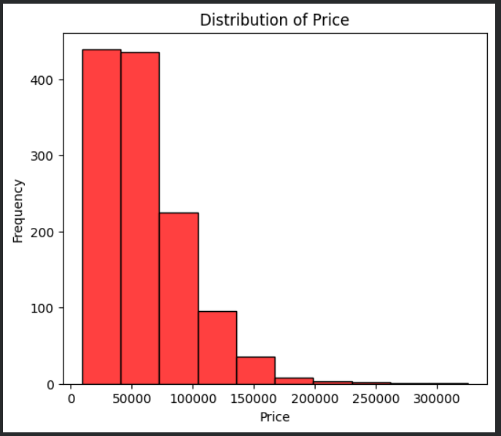

Bivariate Analysis
Bivariate analysis helps explore relationships between two variables, uncovering trends, correlations, and dependencies that impact housing prices.
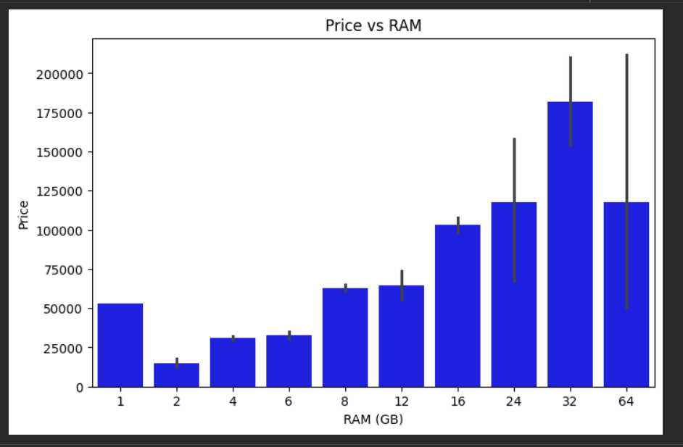

Multivariate Analysis
Multi variate analysis is used to find relationship between multiple attributes, Mostly heatmaps and pair plots are used to find the correlation and relationship between numerical columns. This dataset has only one valid numerical column , Instead of correlation heatmap, other charts show multiple relationships is used.

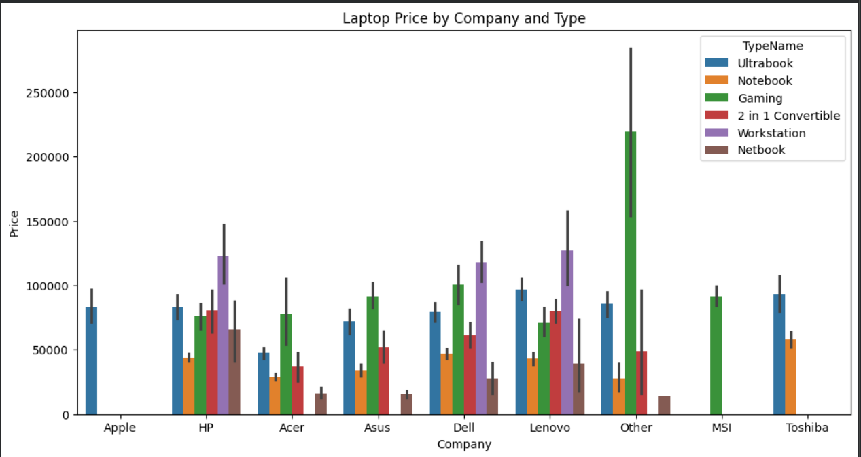

Overall Insights from analysis
  - Laptop prices range from Rs.9k to Rs.3.2 lakh.
  - laptops are highly saled between 0 to 1 lakh and very low saled laptops are between 2 lakhs to 3 lakhs.

Lenovo, Dell and HP is highly Saled and lowest is Apple.
  - 32GB RAM was mostly sale laptops and most lowest is 2GB RAM laptops.
  - RAM vs Price: Strong positive correlation; higher RAM configs almost always cost more.
  - Windows 10 is the most high priced devices to campare then other operating systems and lowest is Linux, Chrome OS, No OS, Android.
  - Other company sale the most number of gaming laptops high price. Notebook Laptops are sale very low to compare all companies.
  - Positive correlation: Inches and Weight, Ram and price, Price and X_resolution, Y_resolution.
  - No correlation: Price and Inches, Weight and Price.
  - Negative correlation: Inches and Touchscreen, Weight and Touchscreen.
  - Storage type price: laptops with SSD are lighter and more expensive compared to HDD models.

  - GPU type: laptops with dedicated GPUs NVIDIA and AMD are more expensive, while those with integrated GPUs are cheaper.
  - Operating systems: majority use Windows, followed by Mac OS (Apple). Linux/No OS laptops are cheaper.
  - Brand premium: even with similar specs, Apple and MSI laptops cost more compared to Acer, Dell, or HP.

Conclusion
This Exploratory Data Analysis (EDA) of laptop data highlights the key factors influencing pricing, including RAM, CPU, storage, GPU, and brand reputation. The study revealed that mid- range laptops dominate the market, while high-end gaming and premium brands significantly increase price ranges. Operating systems like Windows lead in popularity, with MacOS catering to niche users. Outlier detection further identified ultra-expensive models that skew overall distribution. Overall, the analysis provides meaningful insights for consumers to make informed purchase decisions and for manufacturers and retailers to optimize pricing strategies and product positioning in a competitive market.

